1 - WebApi_Handson
Created a .Net core web application with API template.
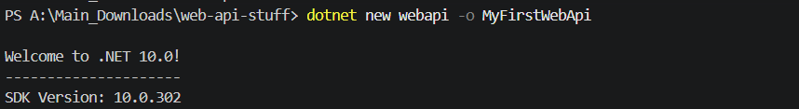
And have used the option to create controller with Read Write permissions. The ValuesController creation has been mapped to the Action methods corresponding to the Action verbs.
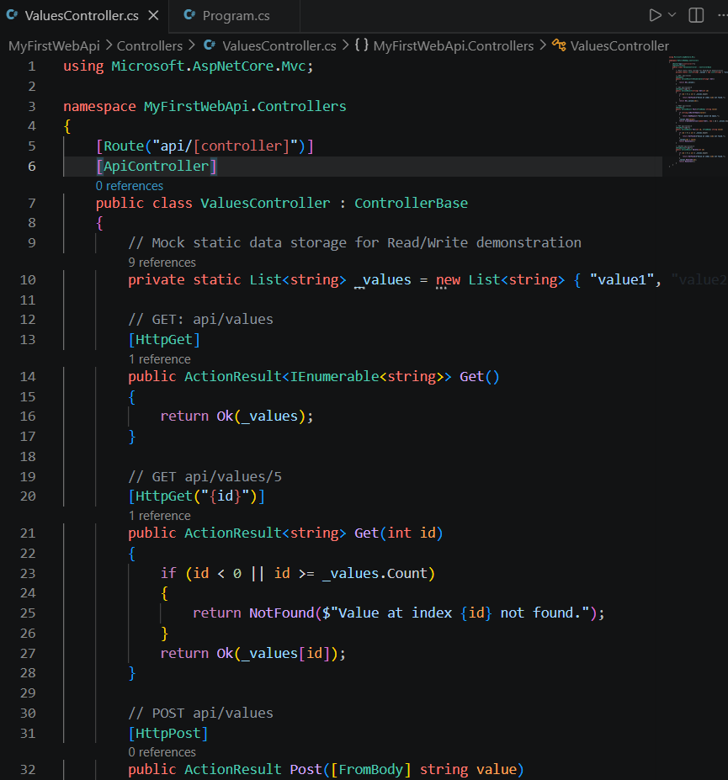
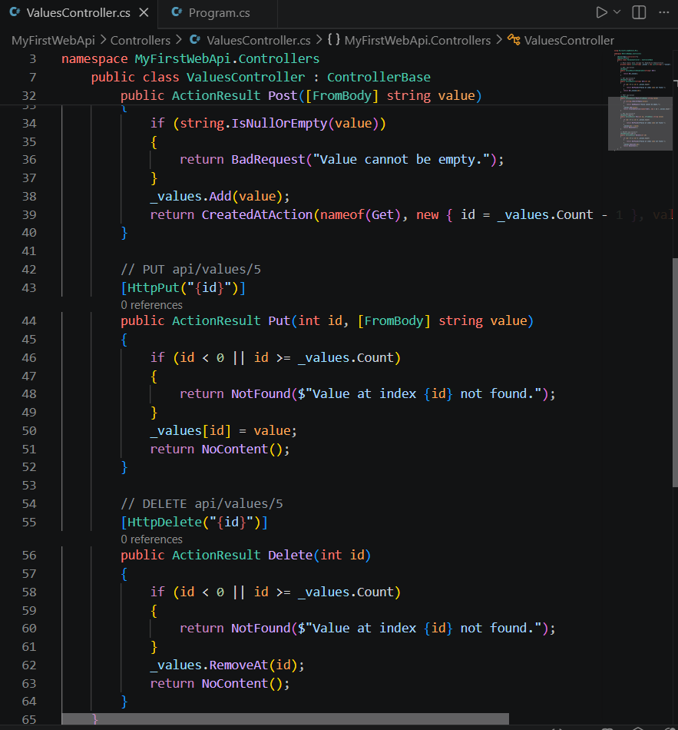
On creation of the Web API, execution the application is done and checking has been done, to check if the GET action method result is returned as expected. And the result it –
